Spring 2019 AppDev Hack Proposal – Aliva Das

Feeling bored on campus? Want to take a break from studying for your prelims? Use

**CUCelebrate!**

An app that shows all the events happening on campus (including but not limited to workshops, lectures and concerts) as well as the time, location and other suitable information.

**Screenshots**

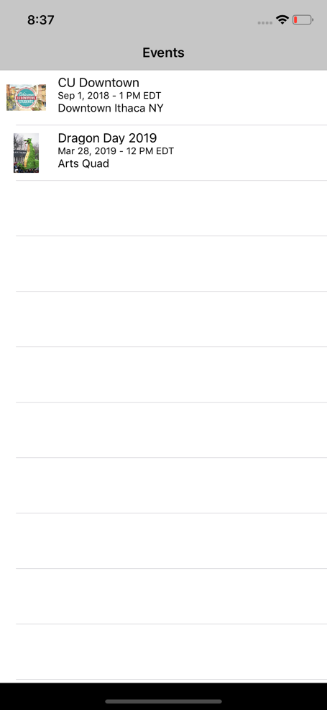 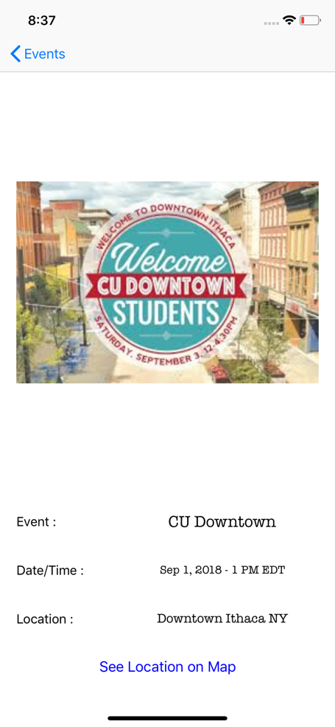 

Overview of UI Elements

* *UINavigationController* - To shift from one screen to another
* *UITableView* – Display list of events (could introduce different sections to organize events by date)
* *UIImageView* – To display images
* *UILabel*
* *UIButton* – On pressing the button named “See Location on Map”, the location of the venue on the map (the third screenshot) appears

API Requirements

* *Google Maps* – For location services
* *Facebook* or other social media – For details of events including time, venue and fees if required (might need to build a database that accumulates data from different sources)